Name: ___________________________________

You will save all of your writing (drafts, rewrites, and final copies) in a Writing Folder that will culminate in a final, end of the year, project. The following assignments are the six main parts of the folder. We will add other writing assignments throughout the year. Please save everything.
Real World Writing Purposes

EXPRESS AND REFLECT
The writer:
- expresses or reflects on his or her own life and experiences, and
- looks backward in order to look forward.

INFORM AND EXPLAIN
The writer:
- states a main point and purpose, and
- presents the information in a surprising way.

EVALUATE AND JUDGE
The writer
- focuses on the worth of person, object, idea, or other phenomenon, and
- specifies the criteria to the person, object, idea, or other phenomenon.

INQUIRE AND EXPLORE
The writer
- investigates a question or problem, and
- examines the question or problem.

ANALYZE AND INTERPRET
The writer
- examines phenomena that are difficult to understand or explain,
- unravels and clarifies.
TAKE A STAND AND PROPOSE A SOLUTION
The writer
- persuades audiences to accept a position on a controversial issue by
- describing the problem, proposing a solution, and providing justification.

Criteria
For each of the six Writing Purposes, you will:
- find five sources,
- complete a notecard for each source,
- choose two sources to use in your paper,
- write a two-three page paper in correct MLA format using parenthetical citation.
The library and its website has all of the information you will need. We are going to help each other with every assignment.

- Sources
We will work throughout the year on evaluating websites and exploring databases.
- Notecards
You can use paper index cards or virtual index cards to document your sources. We will go over how to use NoodleTools in class. All notecards must have the following information.
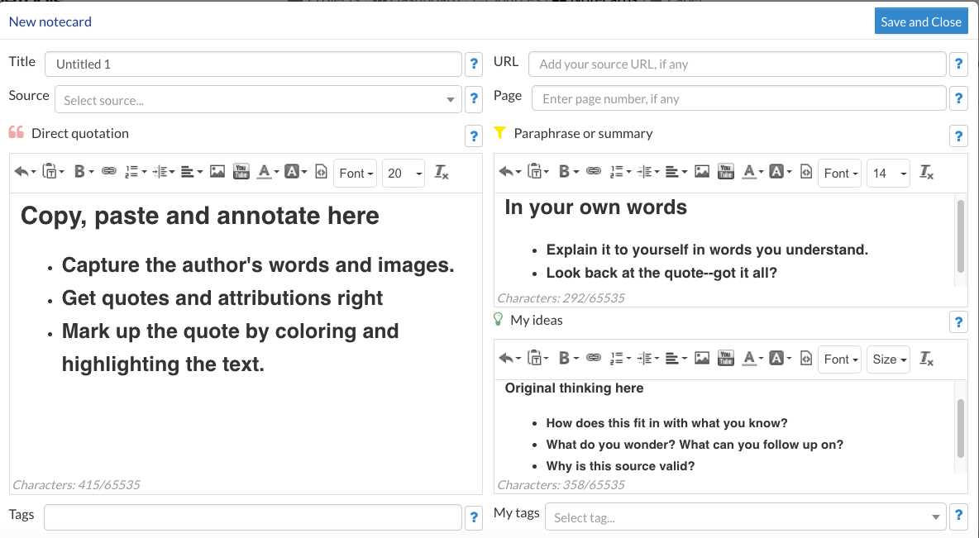
- Choosing sources
Which two sources will work best for you and your paper?
- MLA Format
NoodleTools will help with MLA formatting, and we will go over the basics in class.
Writing Assignment #1 EXPRESS AND REFLECT

For this first writing assignment, we will skip the notecards and research. This two-page paper is personal writing that discuss how something affected/affects you. Below are some brainstorming starter ideas with examples.
1. Sentence Starters
I appreciate ________________ because ______________.

I appreciate FaceTime because it lets me see my grandson Jack almost every day even though he lives in Hopewell Junction.

The __________ made me feel ________________, so now I think about ___________.

The book Persepolis made me feel thankful so now I think about how lucky I am to not live in a war zone.

2. Childhood Memories
Make a list of what your childhood tasted like and/or smelled like.
St. John’s List:
Purple concord grape jelly (homemade by my mother from grapes in the backyard)
Chalky tasting candy cigarettes (I can’t believe they sold these)
Freshen-Up gum (it exploded when you bit into it)

3. Watermark Event
A watermark is a stick placed at the shoreline to measure the depth of tides. After the water receipts, it leaves a mark on the stick showing how high the tide reached. Long after the water is gone, the mark on the stick (the watermark) stays. The watermark is a metaphor for some event in our lives that have left a mark on us.
St. John’s List:
moving to Arizona, going back to college in my 20s, getting into a bad car accident, going to Isla Mujeres for the first time, my father giving away my first dog without telling me…

Whatever topic you choose, remember to use commentary. Commentary answers the question, “So what?” The topic is the bones of the paper. The commentary is the meat.

The book Persepolis made me feel thankful so now I think about how lucky I am to not live in a war zone.
SO WHAT? “I remember my mother telling me about how she grew up during WWII. She was in a P.O.W. camp with her mother and father after they tried to escape Finland through Germany when the Russians invaded.”
