“The Roots and Impact of Antisemitism” Name: _____________________________

“Race is a human invention. We created it, and we have used it in ways that have been in many, many respects quite negative and quite harmful.”
--Race: The Power of an Illusion

Essential Question: What does learning about the choices people made during the rise of the Nazi Party and the Holocaust teach us about the power and impact of our choices today?
Vocabulary
- Anti-Judaism
- Aryan
- Marginalize
- Race
- Racism
- Paradigm
- Eugenics
- Antisemitism
- Xenophobia
Contrary to the beliefs of many people, past and present, race has never been scientifically proven to be a significant genetic or biological difference in humans. Race is socially, rather than scientifically, constructed. There is only one race: human.

Handout
Overview of Anti-Judaism and Antisemitism
Directions: As you are listening to the teacher read, annotate the text by completing the following steps:
- Circle words that are unfamiliar.
- Put a question mark (?) in the margin in places where you feel confused.
- Stop and answer the questions in the boxes. Underline the place(s) in the text where you found the answer to a question.
Judaism is the oldest monotheistic religion. Throughout much of the faith’s history, Jews lived in territories ruled by other groups. They were often treated as outsiders and blamed for disasters suffered by the societies in which they lived. Continuous rumors, lies, myths, and misinformation about Jews have existed throughout history. Many of them persist in the contemporary world. Often this hatred has led to violence.
In 63 BCE, the Romans conquered Jerusalem, the center of Jewish life. They incorporated ancient Israel, the land where the Jews lived, into the Roman Empire. The Romans were brutal rulers who demanded that those they ruled worship their numerous gods. Jews worshipped only one god. The Romans responded with persecution and violence. They destroyed the center of Jewish life, the temple in Jerusalem, in 70 CE. In 130 CE, the Romans attacked Jerusalem again. They displaced much of the Jewish population from the region that the Jews considered their homeland.
Why did the Romans view the Jews as a threat?

During this period of Roman rule, a new faith, Christianity, emerged from Judaism. Jesus and his early followers were Jews. But as Christianity spread after the Romans executed Jesus, early Christians distanced themselves from Jews. This was partly to avoid being persecuted by the Romans. Christianity and Judaism eventually became separate and competing religions. By the 300s, Christianity became the official religion of the Roman Empire. Jews remained a minority.
Over time, lies and myths developed about Jews. Christian Roman society increasingly portrayed them as
“Other.” They were also blamed for various social ills. Among these myths was the false charge that Jews, not Romans, were responsible for the death of Christ. Another powerful lie charged Jews with associating with the devil.
Throughout the Middle Ages, European Christian armies attacked Jewish communities. Jews were also falsely blamed for causing the Black Death. They were forced in some places in Europe to live in ghettos and wear identifying badges. In other places, they were driven away entirely. This happened in 1492. King Ferdinand and Queen Isabella forced Jews to leave the Iberian Peninsula unless they converted. But in the 1500s, not even conversion was enough to save Jews in Spain. The claim emerged among many Christians that those born as Jews had “Jewish blood.” This claim stated that conversion to Christianity did not change Jews’ fundamental identity.
For what events did Christians blame Jews during the Middle Ages?
What were the consequences for many Jewish communities?

Later in the 1500s, Christians known as Protestants broke away from the Church of Rome. Many Protestants thought that Jews would convert to their new Christian faith. When that did not happen, Protestant leader Martin Luther turned on Jews. He called for synagogues and Jewish homes to be set on fire.
The ideas of the Enlightenment had spread across Europe by the 1700s. Among those ideas was that society could be improved through the use of human reason and science and through the ideals of equality. Between the late 1700s and early 1900s, laws and restrictions that discriminated against Jews were lifted in many European societies. In many places, Jews were allowed to participate more fully in the politics, economy, and social life of the places they lived.
As restrictions on Jews loosened across Europe in the 1800s, Jews became more integrated into European society. Some Jews became successful and visible leaders in a variety of professions, and a few became high-ranking government officials. This sparked a backlash from those who continued to be prejudiced against Jews or felt threatened by their increasing success (even though most European Jews remained poor). False conspiracy theories spread across Europe that Jews secretly controlled powerful governments. The theories also stated that Jews controlled financial institutions and sought to enrich themselves at the expense of non-Jewish Europeans.
How did the Enlightenment ideas impact the treatment of Jews in Europe?

During the same period, the field of “race science” emerged in Europe and North America. This happened in part to portray slavery and other divisions in society as “natural.”
Race scientists who divided humans into separate races began to count Jews as a race. In 1878, German Wilhelm Marr popularized the idea that Jews are a distinct and dangerous race. He called them the “Semitic” race. He believed that this race was assaulting Germany and decreasing the fortunes of true “Aryan” Germans. “Aryans” were a mythical, supposedly superior race. Many northern Europeans believed they had descended from the “Aryan” race. Marr coined the term “antisemitism” to describe his belief that Jews were dangerous and should not be allowed to participate in German society.
How did Wilhelm Marr apply ideas of “race” to Jews? How did “race science” support his views?

Antisemitism became common across Europe in the early 1900s. Jews were falsely blamed for the destruction and defeat suffered by Germany and its allies in World War I. They were also blamed for the communist revolution that overthrew the tsar in Russia. Thus, they inspired fear in capitalist societies across Europe. These myths and lies were used to justify increasing discrimination and violence against Jews in the twentieth century.

Antisemitism Today
The Origins of the Swastika
The word swastika comes from the Sanskrit svastika, which means “good fortune” or “well-being." The motif (a hooked cross) appears to have first been used in Eurasia, as early as 7000 years ago, perhaps representing the movement of the sun through the sky. To this day, it is a sacred symbol in Hinduism, Buddhism, Jainism, and Odinism. It is a common sight on temples or houses in India or Indonesia. Swastikas also have an ancient history in Europe, appearing on artifacts from pre-Christian European cultures.
However, the work of European linguists and other scholars was taken up by racist groups, for whom the swastika was a symbol of “Aryan identity” and German nationalist pride. This conjecture of Aryan cultural descent of the German people is likely one of the main reasons why the Nazi Party formally adopted the swastika or Hakenkreuz (Ger., hooked cross) as its symbol in 1920. As a symbol, it became associated with the idea of a racially “pure” state. By the time the Nazis gained control of Germany, the connotations of the swastika had forever changed.
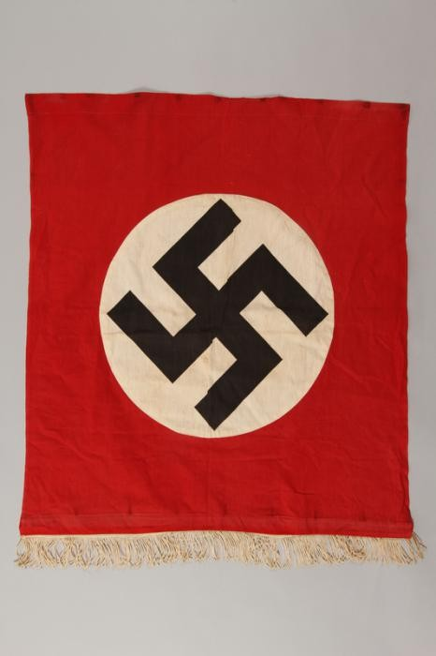
Nazi banner with swastika Ethiopian carved window

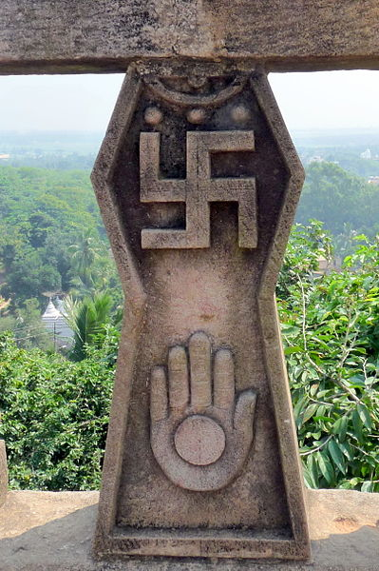

Udaygiri & Khandagiri Caves, Bhubaneswar, India Aztec

How can flags, labels and symbols contribute to the rise of an ideology?
How is the swastika used today? How might the use of the swastika be hurtful or inflammatory?

“What hurts the victim most is not the cruelty of the oppressor, but the silence of the bystander.” –Elie Wiesel

The Anti-Defamation League identified 1,986 anti-Semitic incidents perpetrated throughout the United States in 2017. This is an increase of 57% over the 1,267 incidents reported in 2016. For the first time since at least 2010, an incident occurred in every US state.

October 27 2018
Eleven victims were killed after a gunman armed with an assault rifle and at least three handguns opened fire during a service at a Pittsburgh synagogue on Saturday morning.

Article and four-minute video:
http://time.com/5438424/pittsburgh-synagogue-shooting-anti-semitism/

March 9 2017
A Michigan man and Holocaust-denier who used Twitter to fantasize about killing school children and Jews will be banned from social media and the Internet for two years under supervised probation terms imposed by a judge. David Joseph Lenio, a 31-year-old self-described white nationalist who said his ideal job would be
operating a human gas chamber, also must undergo mental health treatment and not go within 1,000 feet of schools or Jewish synagogues.
November 8 2018
New York City has experienced a 22 percent increase in bias crimes against Jews so far this year, 159 compared to 130 during the same period of 2017, police reported Wednesday. On Monday, New York police arrested a man charged with scrawling pro-Nazi slogans inside a Brooklyn synagogue a week ago.

Adapted from Teaching Holocaust and Human Behavior from Facing History and Ourselves https://www.facinghistory.org/about-us
http://newsreel.org/video/RACE-THE-POWER-OF-AN-ILLUSION
https://encyclopedia.ushmm.org/content/en/article/history-of-the-swastika
https://www.adl.org/resources/reports/2017-audit-of-anti-semitic-incidents

