Making a Notecard Name: ________________________________________

_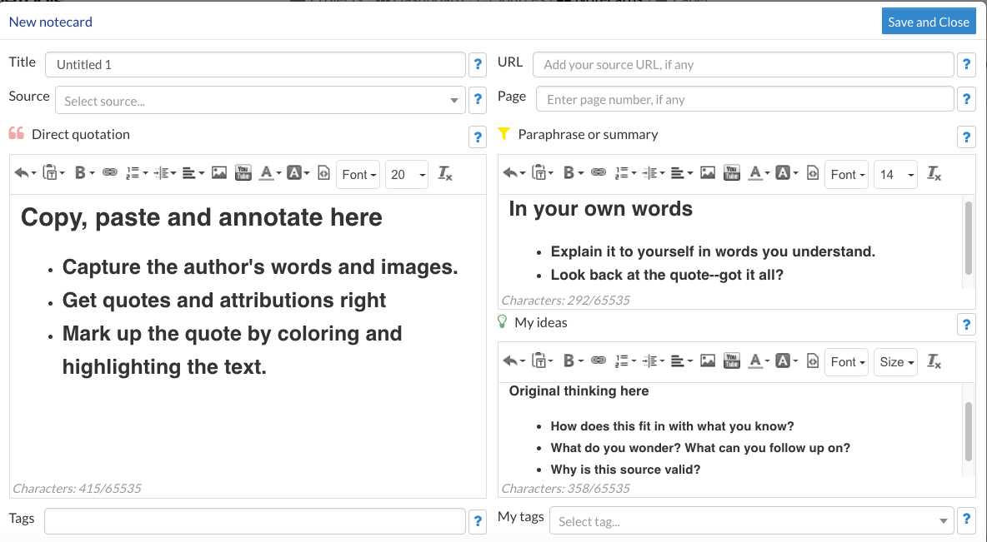

Making a Notecard

- 1. Go to the library website, choose RESEARCH then MAKE CITATIONS, click on Noodletools.
- 2. Register as a new user. Choose “an account linked to a school.” The user name is newpaltzhs and the password is library.
- 3. Create your user ID and password. REMEMBER YOUR USER ID AND PASSWORD! We will use Noodletools throughout the year. Maybe you should write down your user ID and password.
USER ID ______________________________________ PASSWORD _______________________________________
- 4. Click on +NEW PROJECT, and title it “English 9 Take a Stand.”
- 5. Citation style is MLA and citation level is JUNIOR.
- 6. Click on the NOTECARDS tab, then +NEW
- 7. Fill in all of the information except TAGS, the click on SAVE and CLOSE.

When it is time to create your Works Cited page:

- Log in to Noodletools and click on the SOURCES tab then CREATE NEW CITATION.
- Follow the prompts using your notecards for the URL.

